- \Operation\Strip transfer, unit D\Strips transfer
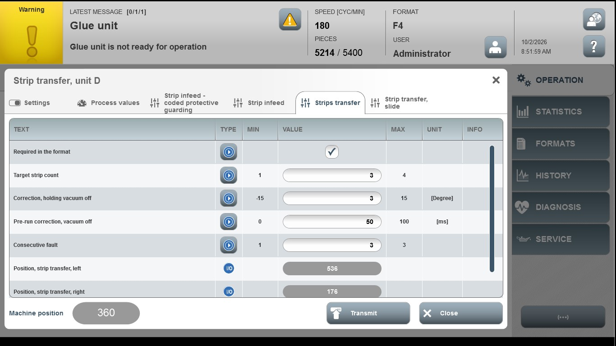

Acceptance criterion | Limits | Pass / Fail: Dev-No. | Date | Initials
Screen matches screenshot | N / A
Target strip count | 1…4
Correction, holding vacuum off | -15…15
Pre-run correction, vacuum off | 0…100
Consecutive fault | 1…3

